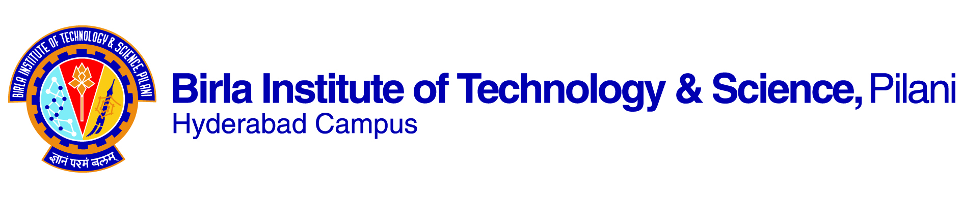

**FIRST SEMESTER 2019-2020**

# Course Handout Part II

01-08-2019

In addition to part-I (General Handout for all courses appended to the timetable) this portion gives further specific details regarding the course.

*Course No. :* CHE F411

## Course Title : Environmental Pollution Control

## Instructor-in-Charge : Dr. D.Purnima

**Course Description:**

This course gives the scope to students to understand air pollutants such as SOx, NOx and their analysis and treatment such as flue gas treatment using scrubbers. Second part of the course covers waste water analysis such as BOD, COD and their treatment to get pure water. Third part of the course covers Solid waste management and fourth part will be dealt with the noise pollution.

**Scope and Objective**

The scope of this course is to study the different types of environmental pollution and the methods to control them

* Understanding different types of environmental pollution and the impact of various pollutants
* To understand the protocols to estimate the extent of pollution by using various analytical tools
* Studying different methods of controlling various types of pollution to meet the desired standards

**Textbooks:**

1. Rao, C.S., Environmental Pollution Control Engineering, New Age International 2nd Ed., 2006
2. Mackenzie L Davis, David A Cornwell. Introduction to Environmental Engineering, Fourth Edition. McGraw Hill, 2010

**Reference books**

1. Peavy, H.S., Rowe, D.R. and Technobanolous, G., “Environmental Engineering” McGraw Hill, 1985.

**Course Plan:**

|  |  |  |  |
| --- | --- | --- | --- |
| **Lecture No.** | **Learning objectives** | **Topics to be covered** | **Chapter in the Text Book** |
| 1 | Introduction: An Overview of Environment pollution control | Overview of environment & its impacts | T1-Ch. 1 &T2 |
| 2-5 | Air Pollution: Sources and Effects | Types of air pollutants, Effect of air pollution, Air pollution laws and standards | T1-Ch. 2&T2 |
| 6-9 | Meteorological Aspects of Air Pollutant Dispersion | Concept of dispersion of pollutants in atmosphere, Understanding of air dispersion models | T1-Ch. 3&T2 |
| 10-12 | Air Pollution Sampling and Measurement | Details of air pollutant samplers | T1-Ch. 4&T2 |
| 13-17 | Air Pollution Control Methods & Equipment  (Control of particulates) | Principles of air pollution control methods, Problems related to these methods (control of particulates) | T1-Ch.5 &T2 |
| 18-20 | Control of Specific Gaseous Pollutants | Various control techniques for criteria pollutants such as SO2, NOX, CO and hydrocarbons | T1-Ch. 6&T2 |
| 21-22 | Source and Classification of Water Pollutants | Introduction to water pollution, Types of water pollutants, Laws & standards of water pollution | T1-Ch.7&T2 |
| 23-26 | Wastewater Sampling and Analysis | Sampling methods, Understanding of concepts of DO, BOD, COD, TOC, inorganic substances, physical characteristics of water | T1-Ch. 8&T2 |
| 27-32 | Wastewater Treatment  (Primary and Secondary & advanced treatment) | Concept of primary and secondary treatment techniques | T1-Ch. 9&T2 |
| 33-35 | Solid Waste Management | Classification of solid waste & Various disposal methods | T1-Ch.10&T2 |
| 36 | Hazardous Waste Management | Classification of Hazardous waste | T1-Ch.11 &T2 |
| 37-39 | Noise Pollution & Environmental Impact Analysis | Understanding of noise pollution & its impact on environment | Study material will be given by IC |
| 40-42 | Laboratory visits | Demonstration of equipment |  |

**Evaluation Scheme:**

|  |  |  |  |  |
| --- | --- | --- | --- | --- |
| **Component** | **Duration** | **Weightage (%)** | **Date & Time** | **Nature of Component** |
| Mid Term Test | 90 min | 25% | 4/10, 9.00 -- 10.30 AM | CB |
| Quizzes | - | 10 % |  | CB |
| Assignments |  | 20% |  | OB |
| Comprehensive Exam. | 3 hours | 45% | 11/12 FN | 15% OB; 35% CB |

**Chamber Consultation Hour:** To be announced in the class.

**Notices:** All notices concerning this course will be uploaded in CMS

**Make-up Policy: Only for genuine cases with prior permission from IC**.

**Academic Honesty and Integrity Policy:** Academic honesty and integrity are to be maintained by all the students throughout the semester and no type of academic dishonesty is acceptable.

**INSTRUCTOR-IN-CHARGE**

**Dr. D Purnima**

**CHE F411**